Sample Application User Guide

Contents

Prerequisites 1

Setup application 1

Azure App Registration 1

Configure the application settings: 3

Run the Application 3

API 5

Create Source Point 5

Delete Source Point 6

Get Catalog 6

Get Points 6

## Prerequisites

To setup the solution, make sure that you have:

* Office 365 Tenant (Business or Enterprise SKU)
* Visual Studio 2017 (Enterprise, recommended)

## Setup application

Follow the steps mentioned below in order to run the application

### Azure App Registration

First step is to create a Custom Redirect URI for the sample app in the Project Smart Link Add-in web application. Make sure that you have Owner access on the Azure subscription before proceeding.

Sign into [Microsoft Application Registration portal](https://apps.dev.microsoft.com). Open the application registered for Project Smart Link.

1. Copy and store the Application Id.

2) Click on **Add Platform.**

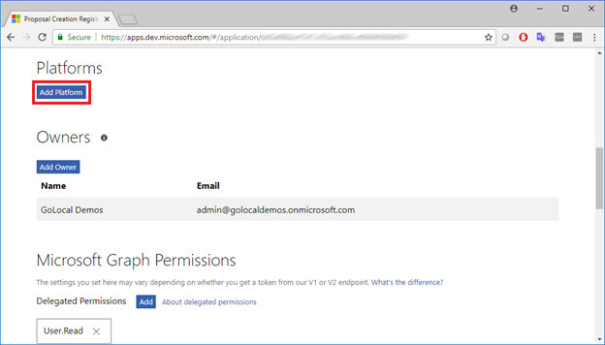

1. Choose **Native Application**.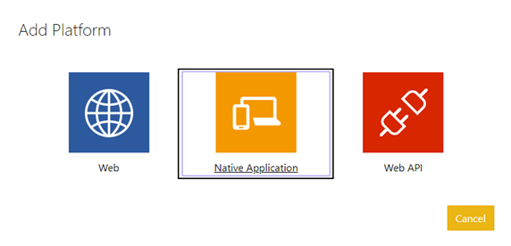
2. Copy and store the Custom Redirect URI that starts with **msal**XXXXXXXX-XXXX-XXXX-XXXX-XXXXXXXXXXXX**://auth**.

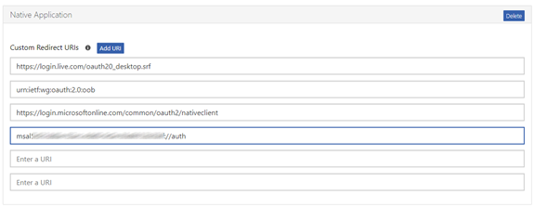

### Configure the application settings:

Open with Visual Studio the solution SourcePointCreator.sln under the Addins\ProjectSmartLink\Sample\SourcePointCreator folder.

In Visual Studio, open the App.Config file and fill the following settings

|  |  |
| --- | --- |
| ClientId | The application id of the registered application in step “Azure App Registration” |
| ApiUrl | The url of the Project Smart Link API, for example: https://myprojectsmartlink.azurewebsites.net/api/ |
| RedirectUri | The Custom Redirect URI created previously. For example: msalXXXXXXXX-XXXX-XXXX-XXXX-XXXXXXXXXXXX://auth |

## Run the Application

Once you completed the application settings, you are ready to run the application. Hit CTRL+F5 to run the application.

When the application starts it will ask for your O365 account, enter your sign in information:

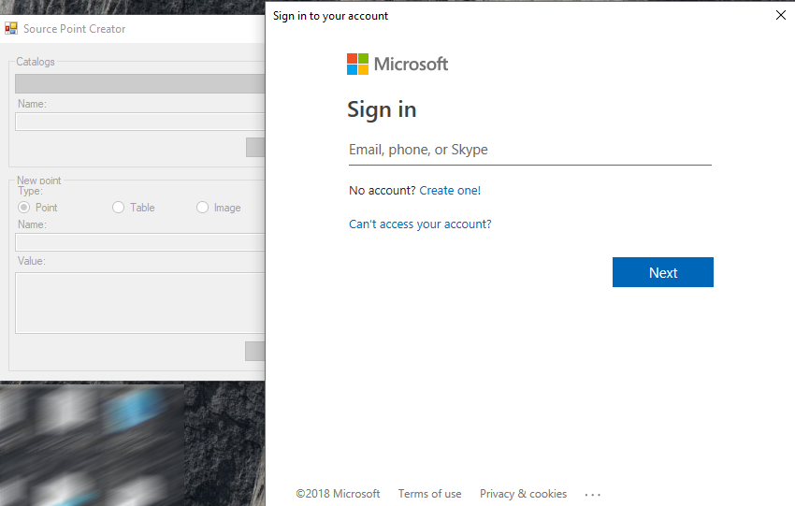

Once you sign in, the application will show the following information:

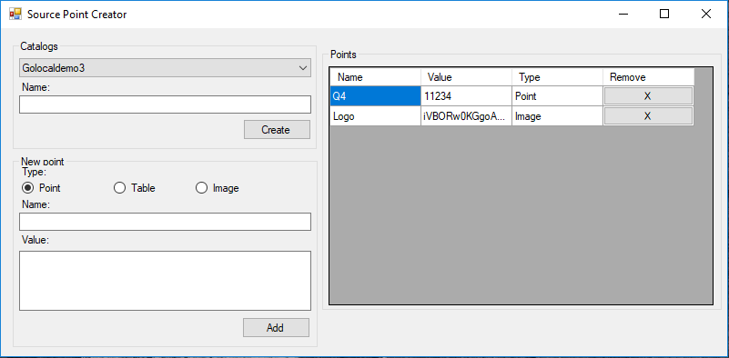

Catalogs: this section displays all the External Catalogs available. You can create a new one by entering a **Name** and clicking on the **Create** button.

Points: this section displays all the available **Source Points** for the selected Catalog. You can remove a point by selecting it from the grid and clicking on the **X** button.

New point: this section allows you to add a new Source Point to the selected Catalog. You need to choose the **Type**, enter the **Name** and **Value** and finally click on the **Add** button.

Source Types:

* Point: this type allows any string or number input: For example: 123456
* Table: this type must apply the following pattern:

|  |
| --- |
| {  "header" : [ "ColumnA", "ColumnB", "ColumnC" ],  "values" : [  [ 1, 2, 3],  [ 4, 5, 6],  [ 7, 8, 9]  ]  } |

* Image: this type must be a base 64 encoded string representation of an image. For example:

|  |
| --- |
|  |

## API

The Project Smart Link exposes a REST API for end users to manage their External Catalogs and Source Points. The API implements OAuth2 Bearer token authorization and in order to consume this API you will first need to acquire a token.

### Create Source Point

URL: api/SourcePoint

Method: POST

Content-Type: application/x-www-form-urlencoded

Payload: SourceType=1&CatalogName=Test&DocumentId=1d1ad07a-f165-4e78-81bc-9bb38098f16b&Name=Fiddler&Value=12345&Creator=me@foo.com&Created=12/27/2018

Parameters:

* SourceType:
  + 1: Point
  + 2: Table
  + 4: Image
* CatalogName: the name of the catalog
* DocumentId: the document id of the catalog, if it’s a new catalog then a guid must be provided
* Name:the name of the source point
* Value: the value of the source point
* Creator: the UPN (user principal name) of the person creating the point. For example: [foo@bar.com](mailto:foo@bar.com)
* Created: the date the source point was created

Note: if the catalog doesn’t exist it will be created.

### Delete Source Point

URL: api/SourcePoint?id=[**id** of the source point]

Method: DELETE

### Get Catalog

URL: SourcePointCatalogs?external=[**true** for external catalogs otherwise **false** for sharepoint catalogs]

Method: GET

Response: an array of SourceCatalogs

|  |
| --- |
| [  {  "Name": "SampleCatalog",  "DocumentId": "b311c636-465a-4a38-b35e-bca43b59be73",  "IsExternal": true,  "IsDeleted": false,  "SourcePoints": [],  "Id": "2144cc89-e4da-44d8-b05e-b99b6b58518c"  },  {  "Name": "Test",  "DocumentId": "1d1ad07a-f165-4e78-81bc-9bb38098f16b",  "IsExternal": true,  "IsDeleted": false,  "SourcePoints": [],  "Id": "92f1d192-7d8c-488b-871f-22a9ffba5c71"  }  ] |

### Get Points

URL: SourcePointCatalog?documentId=[the **document id** of the catalog containing the source points]

Method: GET

Response: a SourceCatalog containing the collection of Source Points

|  |
| --- |
| {  "Name": "SampleCatalog",  "DocumentId": "b311c636-465a-4a38-b35e-bca43b59be73",  "IsExternal": true,  "IsDeleted": false,  "SourcePoints": [  {  "Name": "Q4",  "RangeId": null,  "Position": null,  "Value": "11234",  "Creator": "foo@bar.com",  "Created": "2018-12-26T09:53:28.9633534",  "Status": 0,  "SourceType": 1,  "NamePosition": null,  "NameRangeId": null,  "CatalogId": "2144cc89-e4da-44d8-b05e-b99b6b58518c",  "Groups": [],  "PublishedHistories": [  {  "SourcePointId": "260bdf25-4eaf-4ba0-b82a-08d66b5b0afd",  "Name": "Q4",  "Position": null,  "Value": "11234",  "PublishedUser": "foo@bar.com",  "PublishedDate": "2018-12-26T09:53:28.9633534",  "Id": "6bf9bf18-5b81-47b1-8917-33bd2a704333"  }  ],  "Id": "260bdf25-4eaf-4ba0-b82a-08d66b5b0afd"  },  {  "Name": "Logo",  "RangeId": null,  "Position": null,  "Value": "",  "Creator": "foo@bar.com",  "Created": "2018-12-26T06:40:32.8273856",  "Status": 0,  "SourceType": 4,  "NamePosition": null,  "NameRangeId": null,  "CatalogId": "2144cc89-e4da-44d8-b05e-b99b6b58518c",  "Groups": [],  "PublishedHistories": [  {  "SourcePointId": "12f71c0f-8d1f-488a-6757-08d66b3e1098",  "Name": "Logo",  "Position": null,  "Value": "",  "PublishedUser": "foo@bar.com",  "PublishedDate": "2018-12-26T06:40:32.8273856",  "Id": "354d3c45-6145-4cea-8b64-c1d4a6b99c7f"  }  ],  "Id": "12f71c0f-8d1f-488a-6757-08d66b3e1098"  }  ],  "Id": "2144cc89-e4da-44d8-b05e-b99b6b58518c"  } |